8th Grade Fundraiser
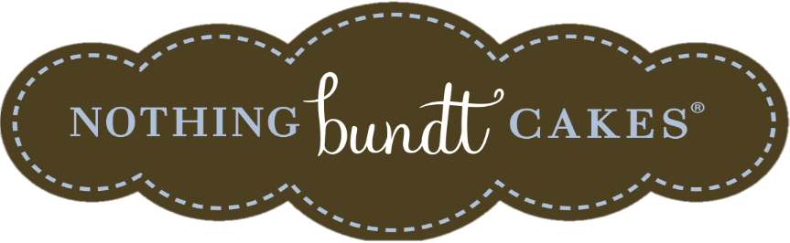
The Class of 2018 is raising money to help fund their 8th Grade Legacy Gift. Nothing Bundt Cakes is a delicious way to help us toward the goal! If you aren’t familiar with Nothing Bundt Cakes, they are luscious concoctions of premium ingredients including fresh eggs, real butter, and delicious cream cheese frosting!
These will be available for pick up on Friday, February 9th...just in time for your Fat Tuesday or Valentine’s Day celebrations.
Available flavors are
Chocolate Chocolate Chip
Red Velvet
White Chocolate Raspberry
Classic Vanilla
Gluten-Free Chocolate Chocolate Chip

Please return the order form to the office with your check or cash in an envelope marked 8th Grade Fundraiser.
ORDER DEADLINE: Thursday, FEB 1st Pick up at ASCA after 3PM Friday, February 9th
------------------------------------------------------------------------------------------------------------------------------------------
All Bundlets are 6.00 each Each Bundlet is a generous single serving
Name: __________________________________________
Phone: __________________________________________
Email: ___________________________________________
Flavor | Qty | Price | Total
Chocolate Chocolate Chip |  | 6.00
Red Velvet |  | 6.00
White Chocolate Raspberry |  | 6.00
Classic Vanilla |  | 6.00
Gluten-Free Chocolate Chocolate Chip |  | 6.00
Total

Questions? Contact Robin Beck @ 630-362-8746 or robindbeck24@gmail.com

